Develop A Web Application Using Node-RED

|  |  |
| --- | --- |
| Date | 01 November 2022 |
| Team ID | PNT2022TMID48656 |
| Project Name | Project - IoT Based Safety Gadget For Child Safety Monitoring & Notification |
| Maximum Marks | 2 Marks |

Steps Followed:

* Opened a Node-RED project

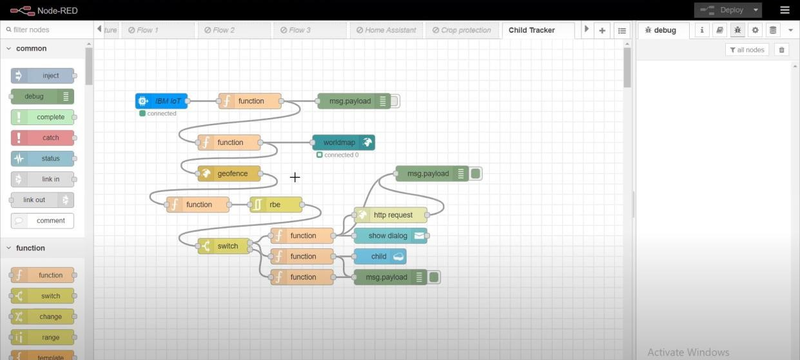

* Added code to get child location in python

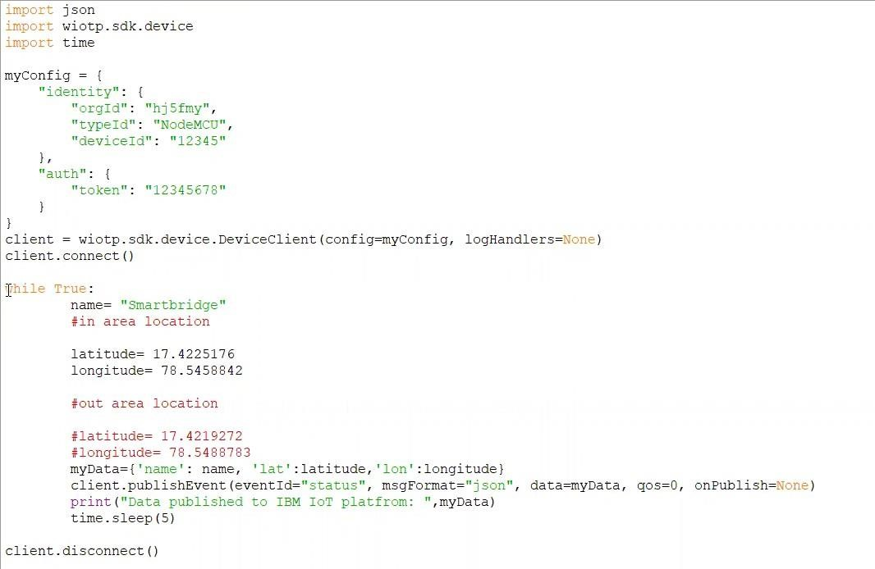

Created GeoFence

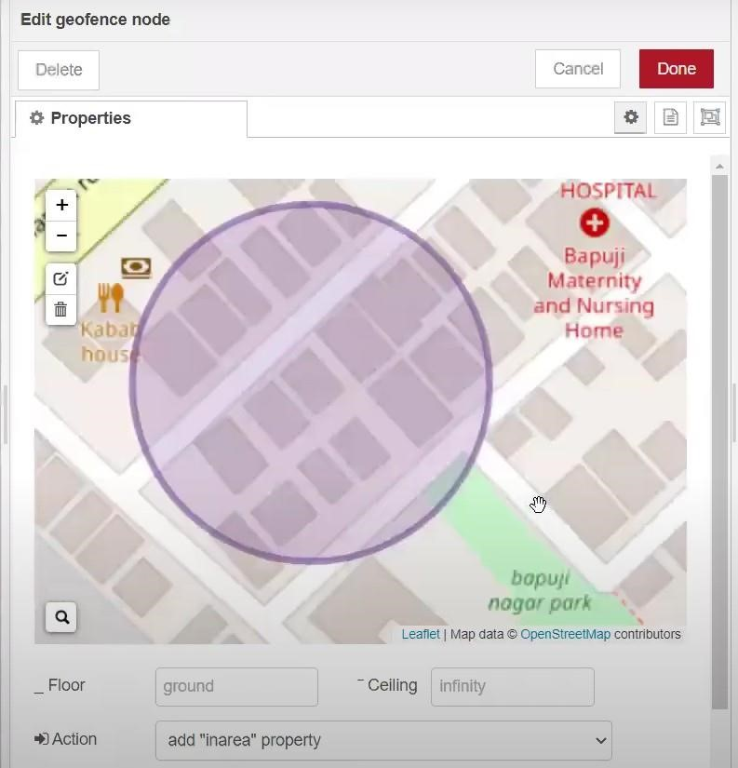

Editing HTTP Request URL

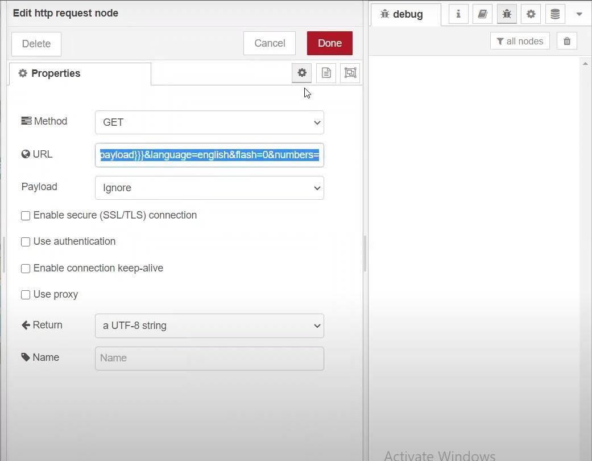

* Located the child

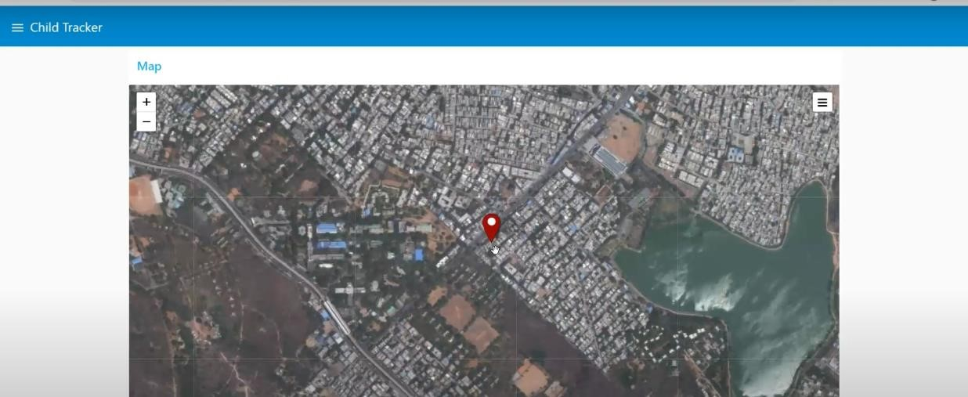

Created geofence node

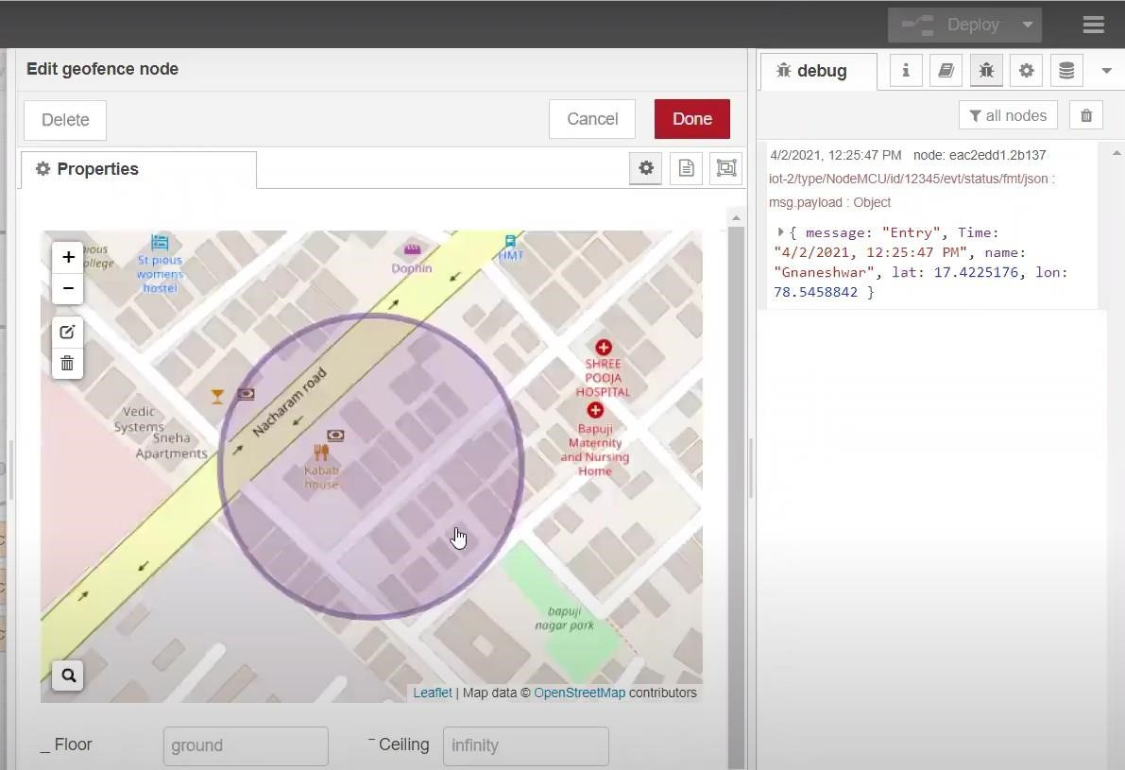

* Python script sending requests to IBM Cloud

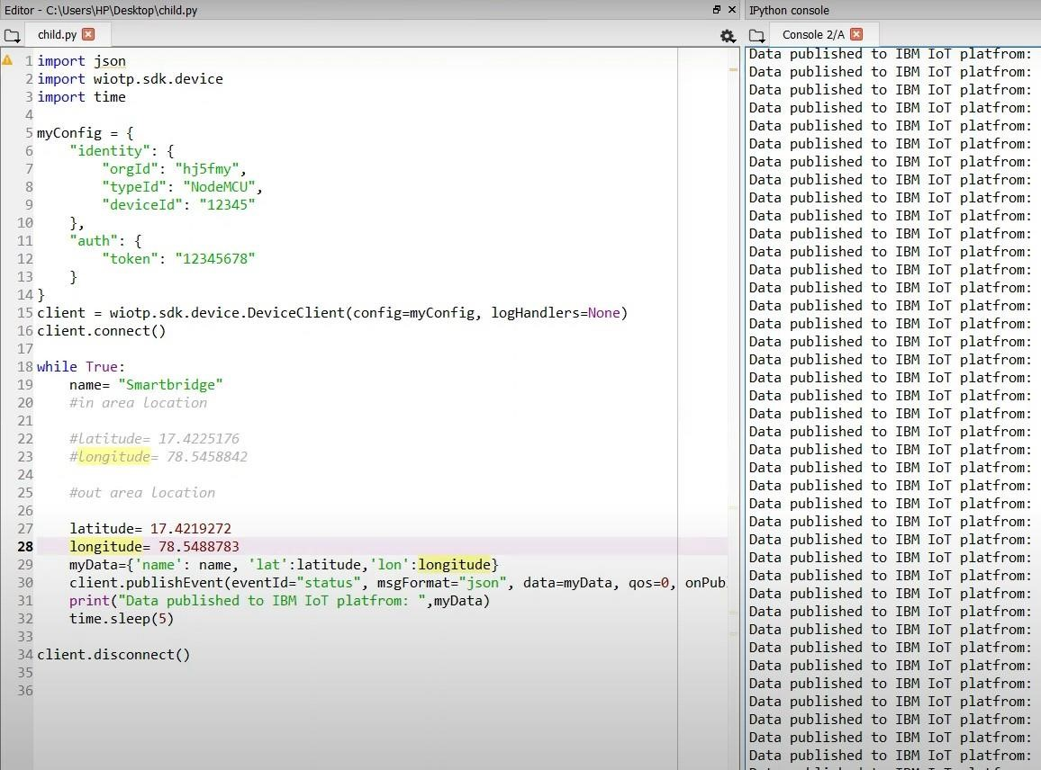

After running the script, the web UI shows “Person is not in the particular area”

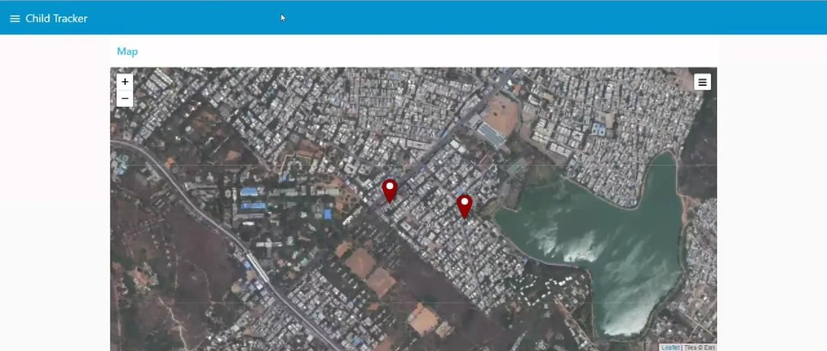

Result: Successfully developed a web application using Node-RED